LIGHT is a six-year cross-disciplinary global health research programme funded by UK aid, led by the Liverpool School of Tropical Medicine in collaboration with partners in five countries i.e. Kenya, Malawi, Nigeria, Uganda, and the UK. LIGHT aims to support policy and practice in transforming gendered pathways to health for people with TB in urban settings. This will lead to enhanced overall health and well-being, improved socio-economic outcomes, equity, and will contribute to the efforts of ending TB.
ReSok is the research partners for LIGHT in Kenya that is carrying out a research project on “High TB prevalence among young people in Kenya: an assessment of critical gaps in the tb care cascade using a gender lens” This study aims to understand the burden of tuberculosis among young people, especially young men, to enable the development and testing of tailored interventions to address this burden.
To achieve this, the LIGHT research team will carry out the following activities:
- TB care cascade analysis to determine risk factors for non-completion of screening, diagnostic and treatment steps among young people in Kenya, allowing for prioritisation of resources and optimisation of TB care among young people.
- Systematic review of qualitative studies on TB care related challenges and opportunities experienced by young people in Nairobi County.
- Participatory research to design a theory-informed TB care related intervention for young people in Kenya that would be tested at a later stage using Randomised Control Trials (RCT)- if funding allows.
- Participatory workshops with healthcare workers providing TB services in Nairobi to advance person-centred, rights-based, gender-responsive TB prevention and care in Kenya.

On 16th January, the ReSoK and AFIDEP teams held a meeting with the officials from the Ministry of Health, the National TB program, Kenya to deliberate on how the studies will be conducted in the country.
While gender disparities continue to be a challenge in the TB response, NTP Kenya is resorting to evidence to inform the development of its policies. Achieving this requires tangible actions including open and transparent conversations, asking critical questions, and long-term commitment as well as accessing gender-segregated data across various digital platforms/ resources. The latter helps generate valuable data, facilitating informed decision-making and ultimately improving the lives of citizens.

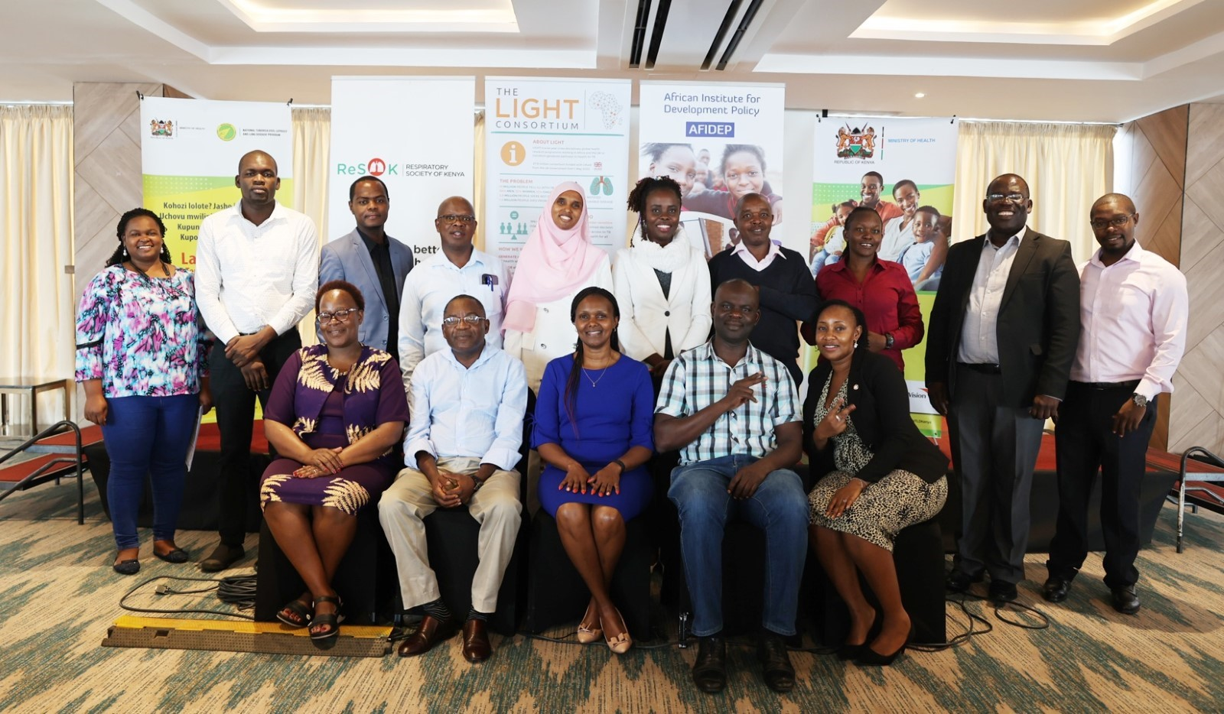
Caption: LIGHT Consortium partners in Kenya, AFIDEP and ReSoK with National Tuberculosis, Leprosy and Lung Disease Program (NTLD-P) members during the breakfast engagement meeting held on 17 January 2024.

LIGHT Consortium partners in Kenya, comprising the African Institute for Development Policy (AFIDEP) and the Respiratory Society of Kenya (ReSoK) actively sought engagement with the Ministry of Health’s National TB Programme team on 16th January 2024. This collaboration is pivotal considering the crucial role of the National TB Programme in ensuring that TB control initiatives address gender-specific challenges and promote equitable access to healthcare services at both the national and county levels.

This engagement aimed to present the protocols of two LIGHT research studies conducted by ReSoK and AFIDEP and seek partnership with the National TB Programme. One of the studies focuses on identifying the critical gaps in the TB care cascade among young people (aged 15-24 years) in Nairobi County, through a gender lens. Recognizing that effective screening is fundamental along the TB cascade, including diagnosis, treatment initiation, and treatment outcomes, the study aims to analyze the Kenyan TB care cascade, assessing losses attributed to various gaps and determining risk factors for non-completion of screening, diagnostic and treatment among young people with TB. This study's outcomes will guide the health systems structure to develop and implement gender-specific interventions across the different levels of care.

Speaking at the event, the acting Head of the National Tuberculosis, Leprosy and Lung Disease Programme (NTLD-P), Dr Immaculate Kathure, emphasized the importance of viewing gender through an unbiased lens, acknowledging its pivotal role in TB approaches. This could fast-track the gains achieved to end TB as per WHO’s end TB strategy by 2030. Despite the Ministry’s various Programmes, the development of a protocol to help advance policies in addressing the issue of TB and gender cannot be ignored.
This was also echoed by Prof. Jeremiah Chakaya, the CEO of ReSoK who stated that “Apart from Afghanistan which has more women with TB than men, globally TB is still more in men than women. Various biological, social, cultural and behavioral factors have influenced this. Addressing the gender dimensions of TB in Africa requires a comprehensive approach that considers these factors.” Efforts should focus on tailoring interventions to the specific needs and vulnerabilities of both men and women in diverse communities across the continent.
Kenya’s TB landscape shows that health policies are designed to endorse equity, human rights-based, people-centered, and participatory approaches to health and health interventions. Kenya’s National Strategic Plan for Tuberculosis (2019-2023) identifies specific population groups vulnerable to TB as key to a successful TB response, focusing on “person-centered care” as one of its three pillars, despite adopting these approaches, the end-term review of the strategic plan suggests that patients are largely managed in the same way with limited attempts to tailor care for according to individual circumstances. This suggests a gap in the implementation of these approaches within the TB healthcare strategies.
The second research study seeks to address the policy-practice gap through face-to-face workshops with healthcare workers and TB stakeholders. The main objectives of the study are to explore healthcare workers’ understanding of and experience in person-centred, rights-based, gender-responsive TB services; explore perceived opportunities, challenges and needs among healthcare workers towards implementing these services; as well as facilitating learning between healthcare workers and stakeholders to generate opportunities.
Outcomes of the study aligned to basic ethical practices will include enhanced understanding, good practice and provide recommendations with agreed plans of action.

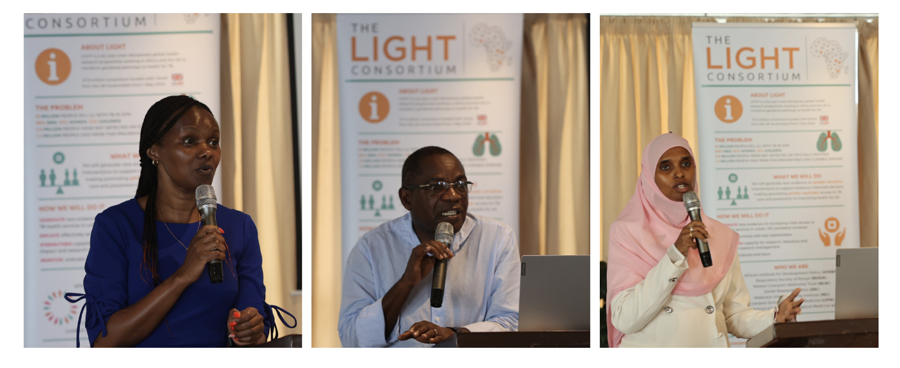
Caption: From left: Dr Immaculate Kathure, acting Head, NTLD-P, Prof. Jeremiah Chakaya, CEO, ReSoK and Dr Leyla Adbullahi, Senior Research and Policy Analyst, AFIDEP addressing participants.

The LIGHT consortium partners, underscoring a participatory approach, sought to get data within the National TB Programme’s TIBU (National TB surveillance system) to help present the findings through round table discussions and other forums to elicit various reactions based on gendered approaches used. Not to mention, walk the journey together to have an understanding and provide direction while speaking one voice.
The data on screening will provide insights/evidence on difference between men and women and assess whether the approaches are pro-men or women. Having this good relationship with partners will help consolidate ideas and inform the TB fraternity and the government in coming up with working policies. Implementing gender-sensitive strategies is crucial for effective TB control and ensuring equitable access to healthcare.
In summary, the meeting participants reached a unanimous decision to champion a collaborative work methodology and implement a research-oriented approach to tackle gender-related challenges in the country's TB context. The Monitoring and Evaluation (M&E) team provided assurance that they would conduct data mining for the specified variables within a week, collaborating closely with the LIGHT team for subsequent analysis. Anticipating preliminary results, the team plans to reconvene for another meeting before convening a broader stakeholder gathering to share insights and findings. This cohesive strategy reflects a commitment to a thorough and inclusive process in addressing gender-related issues in the context of TB.

The TB symposium
On 14th of March, the Respiratory society of Kenya with support from the LIGHT Consortium in collaboration with Kenyan’s Ministry of Health, Division of National Tuberculosis (TB), Leprosy and Lung Disease Program and the organising committee comprising Kenya Medical Re-search Institute, Centre for Health Solutions – Kenya (CHS), Stop TB Partnership Kenya and Kenyatta National Hospital, held a TB symposium as a pre–World TB Day event.
Key symposium highlights include:
- Comprehensive and engaging panel discussions on various TB topics
- Exhibitions showcasing advancements and challenges in TB diagnostics
- Special focus on Kenya’s progress, challenges, and strategies in dealing with TB
- Exploration of the gender dimension of TB, emphasizing the underrepresentation of men
- In-depth analysis of TB prevention, its significance, rationale, and effective implementation strategies, among others.

The objectives of the symposium were to;
- Introduce the work of the LIGHT Consortium in addressing issues related to health and wellbeing in Kenya.
- Create awareness among the policymakers and stakeholders in Kenya on need for collaboration in gender-responsive approaches to end TB.
- Share the latest evidence on the TB burden in Kenya and provide recommendations to policy-makers and practitioners, including distributing of published documents.
The Symposium was a one-day event hybrid meeting with (229) participants (Delegates, Speakers/Presenters, and those from the Media) attending physically and over (400) participated virtually (online).

TB SYMPOSIUM 2024 PICTORIALS
